BREAKFAST CHATTER
Weekly Bulletin of Rotary Club of Kathmandu Mid-Town
District 3290 Volume No. 15/23 for #765 December 31, 2004
www.rotarymidtown.org.np
DECEMBER IS ELECTION OF NEW BOARD MONTH
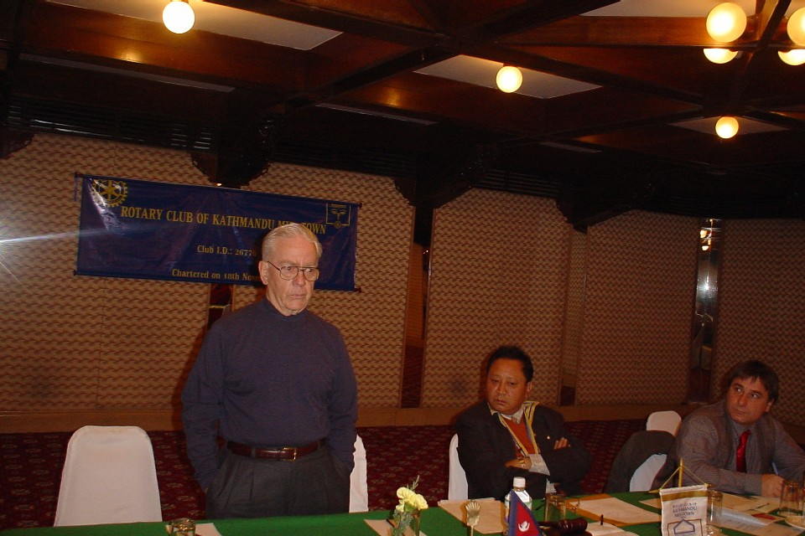
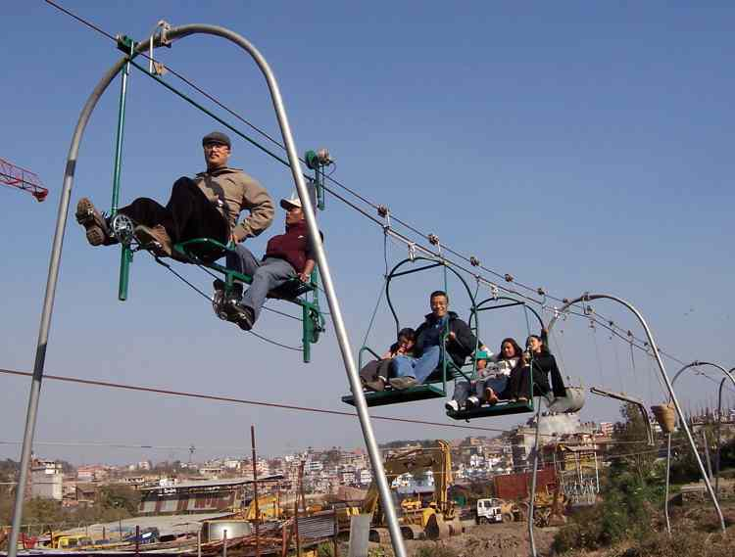
SUNSHINE ANNOUNCEMENT FOR THE (c-cold!) WEEK OF 31 DECEMBER 2004; A distant ‘happy anniversary’ and best wishes to our far-away Rotarian Robert and Giannina!…!!!!!!!!!!!!!!!!!!!!!!!!!!!!!!!!!!!!!!!!!!!!!!!!!!!!!!!!!! And a fond farewell to our friend of many years and countless meetings: Luke Sunde. We wish him happiness and great satisfaction for the good he has done for so many people. ^ Luke’s Farewell ^
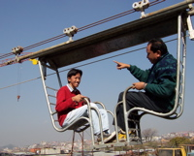
Kailash, Roop & children ride the WireRoad>>>>>>>>>>>>>>>>>>
<<<<<Arun rides the WireBridge

***********
MEETING ACTIVITIES:
DATE | ACTIVITY | SUBJECT
31 DEC | Fr. Bill Robins | Social Service and Peace in Nepal
7 JAN | Subarna Joshi | Community Participation in Local Area Development
14 JAN | ADRA | Youth Reproductive Health Education Project (ABC)
**************** NEWS: Rotarians are gathering contributions for victims of the tsunami. Please contact Rtn Navyo or Arun if you choose to help. *** ****************
We have the pleasure of Fr. Bill Robins as our speaker on this the last day of 2005. Please join us in sharing his thoughts on social service and its contribution to peace in this, a year of ‘interesting times’.
**************** YIR…David

